**Setting up the db:**

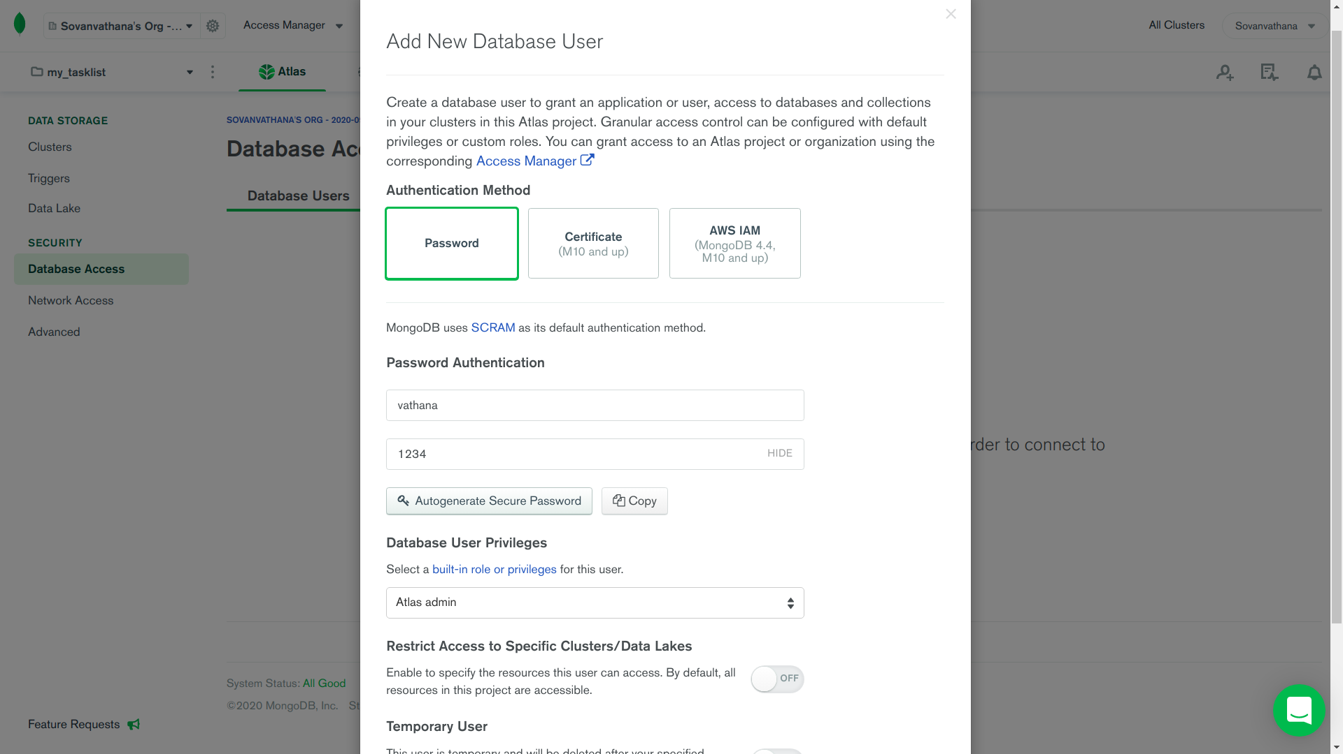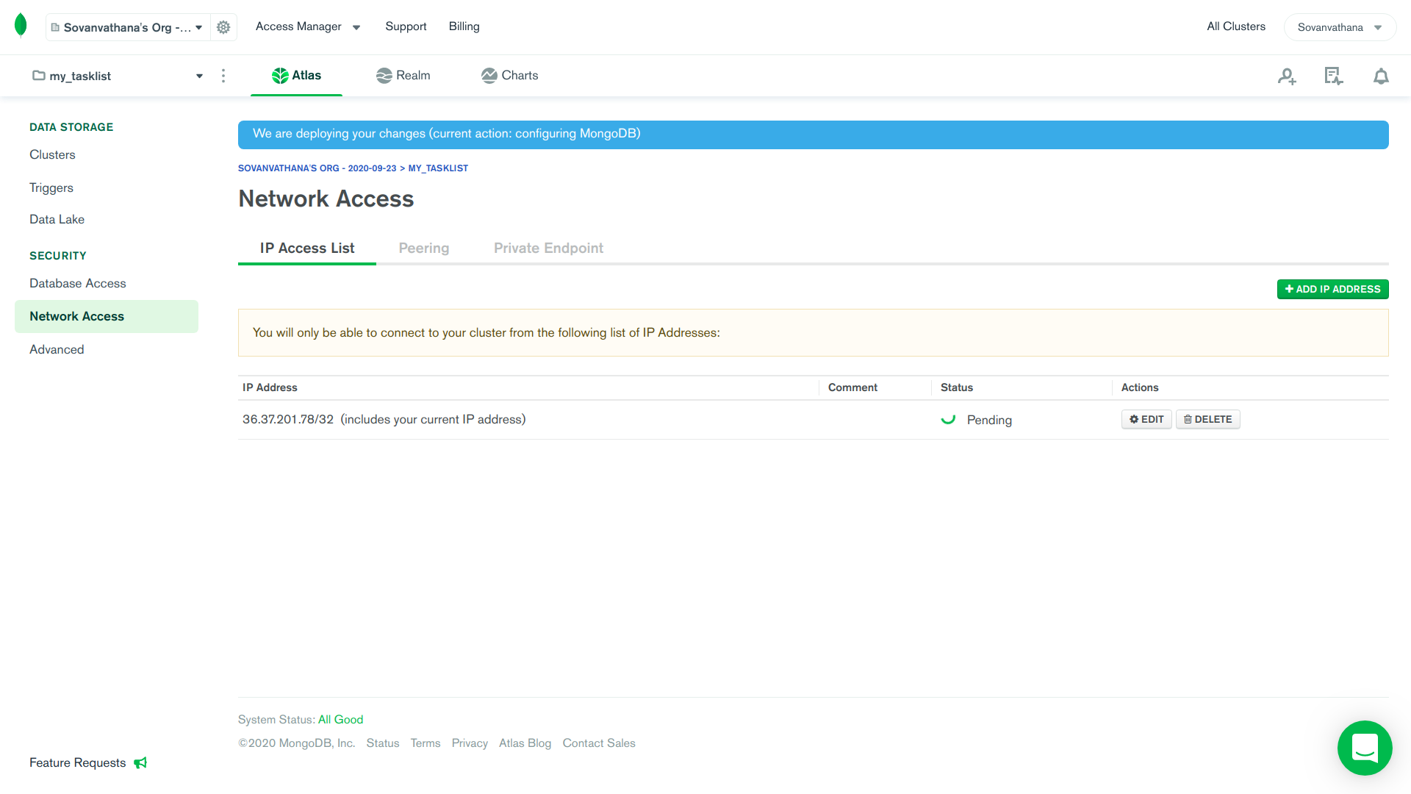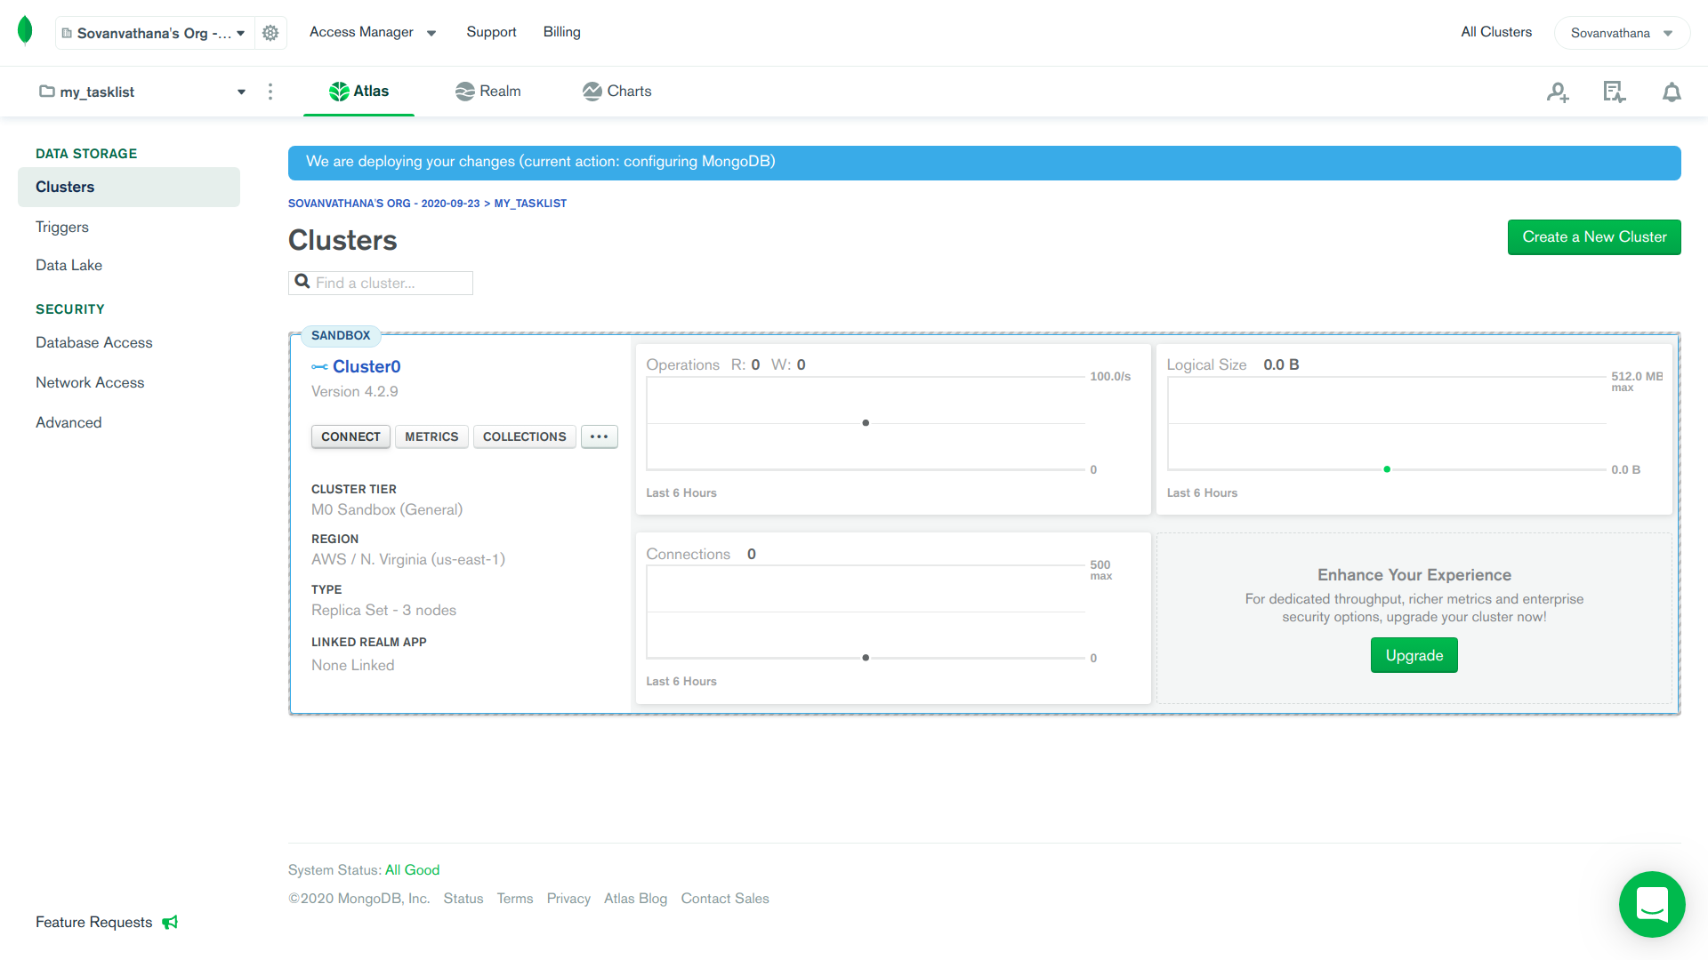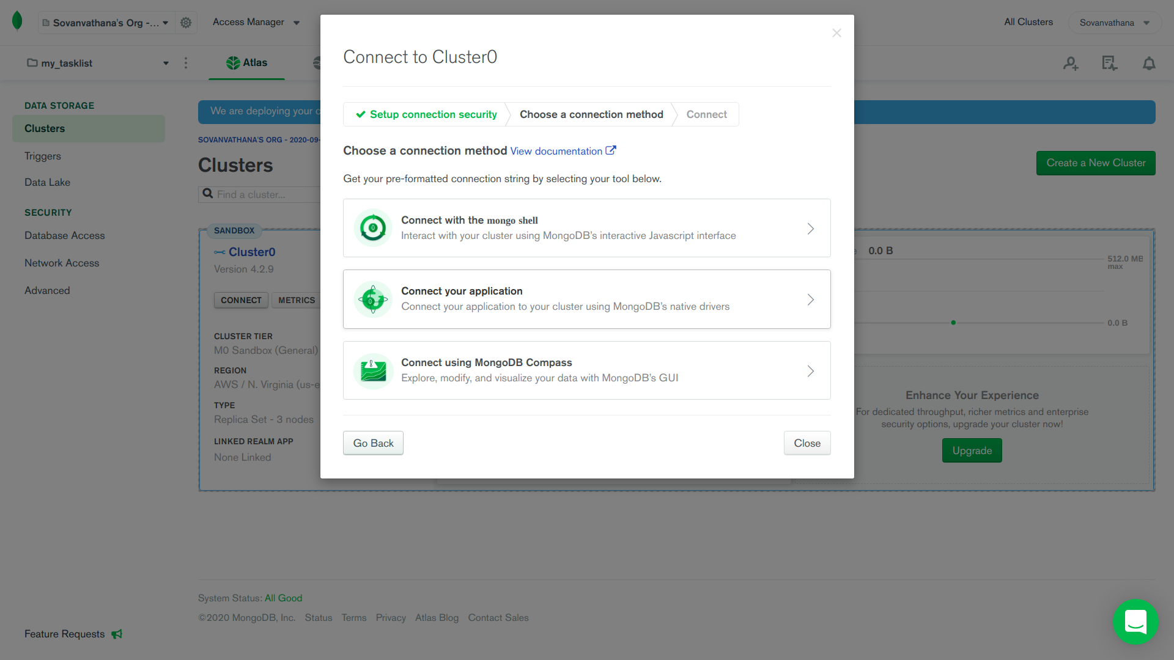

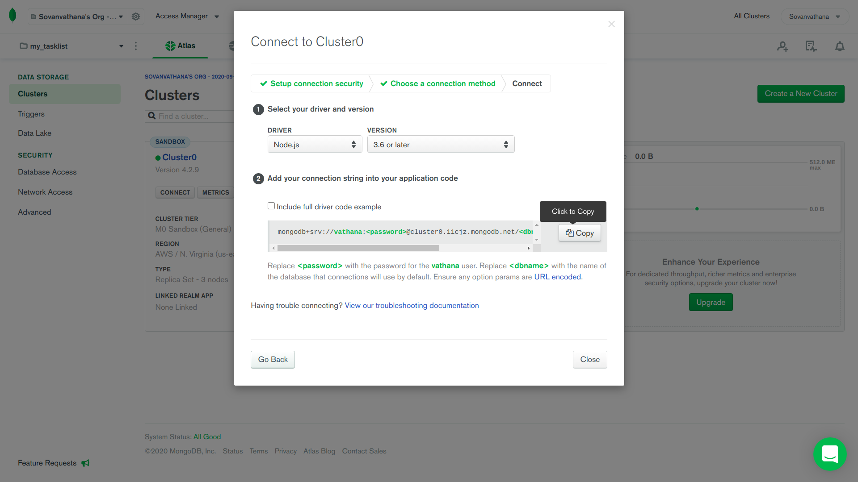

**Setting up the project:**

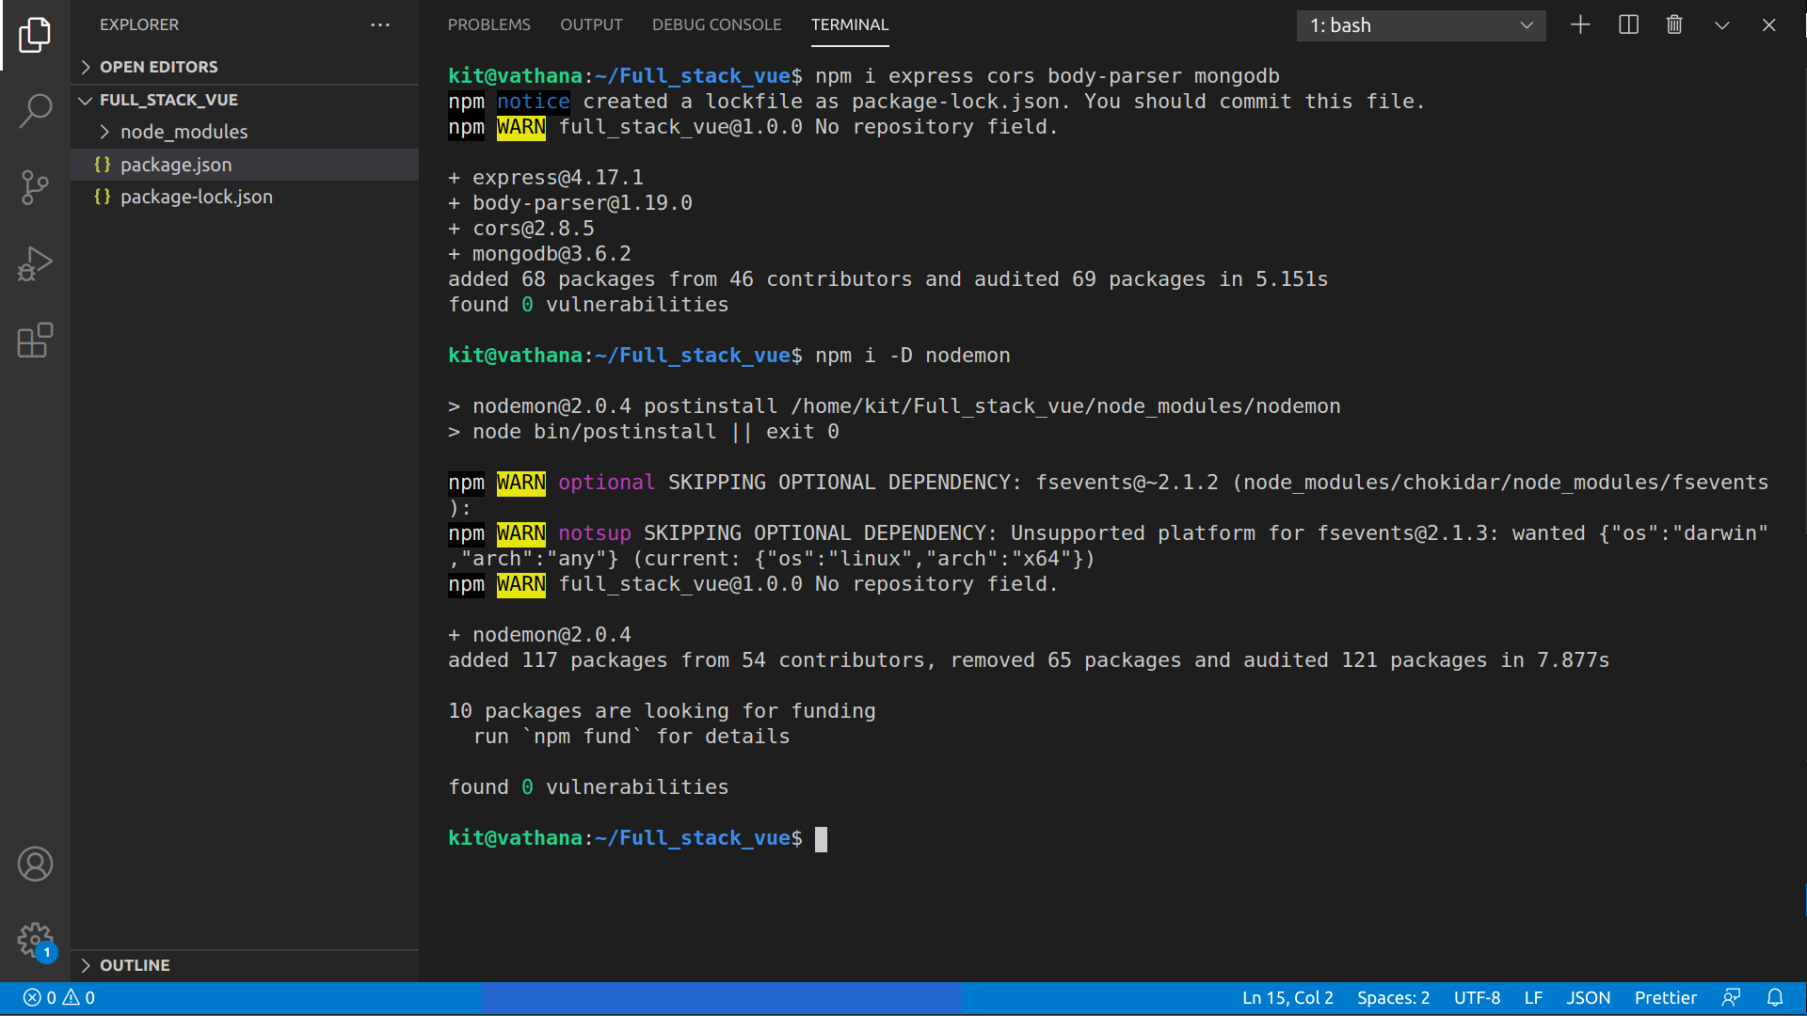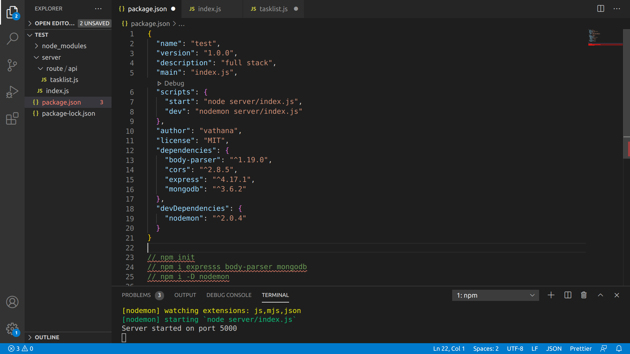

**Dependencies Express:** value is used to specify any other modules that a given module (represented by the package. json ) requires work. When you run npm install from the root folder of a given module, it will install any modules listed in that dependencies hash.

**Dependencies Cors:** is a node.js package for providing a Connect/Express middleware that can be used to enable CORS with various options.

**Dependencies body-parser:** Parse incoming request bodies in a middleware before your handlers, available under the req.body property.

**Dependencies nodemon:** is a tool that helps develop node.js based applications by automatically restarting the node application when file changes in the directory are detected.

**Dependencies mongodb:** Provides a high-level API on top of mongodb-core that is meant for end users.

**Setting up the middleware:**

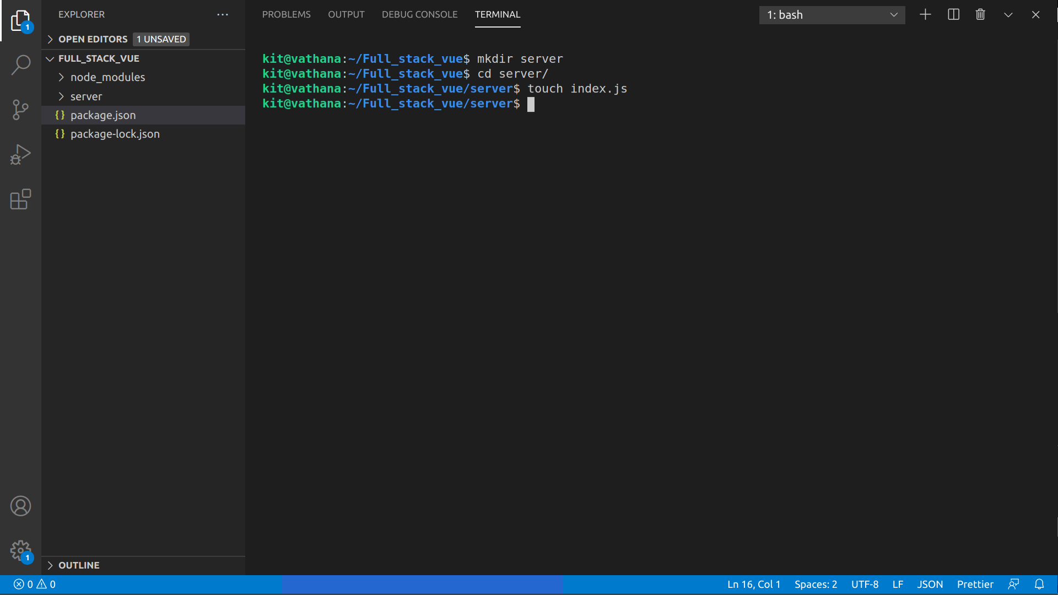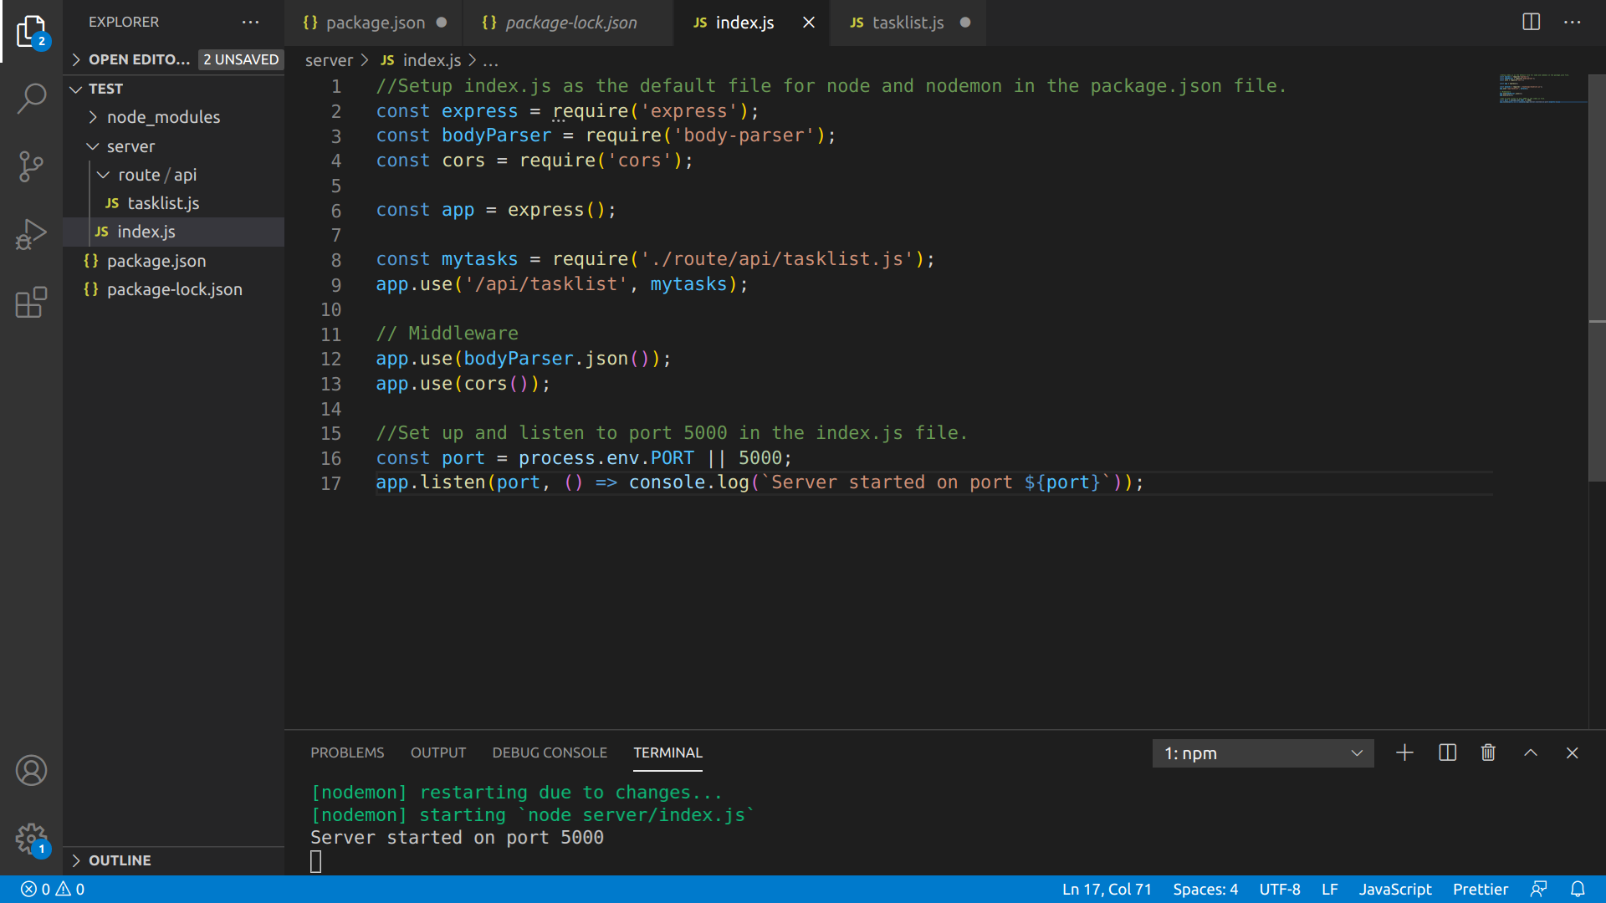

**Creating the API methods:**

